**Demographic Variables**

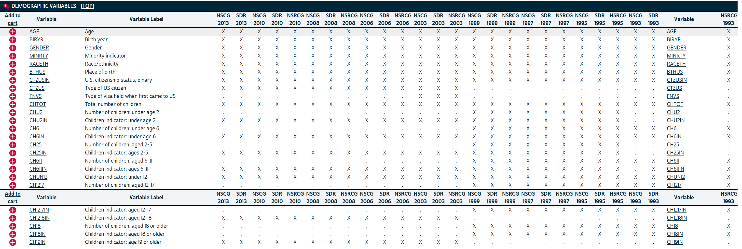

**Education Variables**

Highest Degree

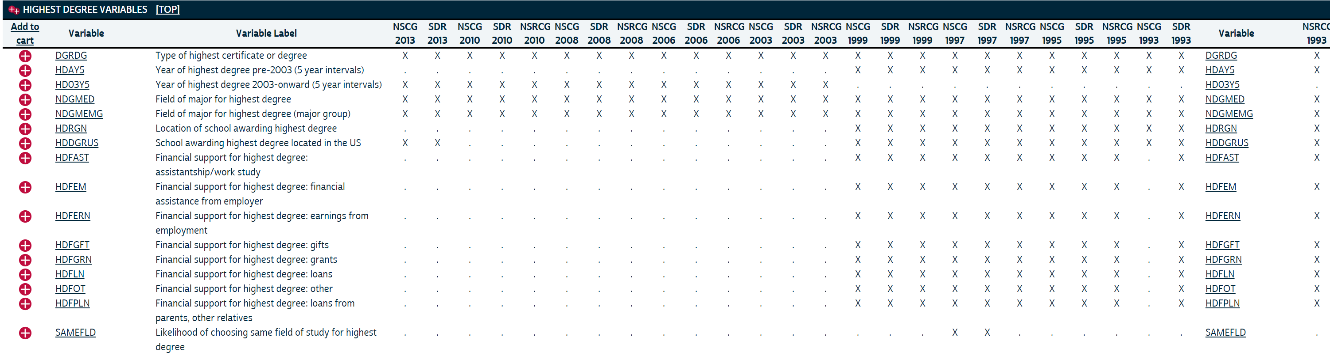

MOST RECENT DEGREE

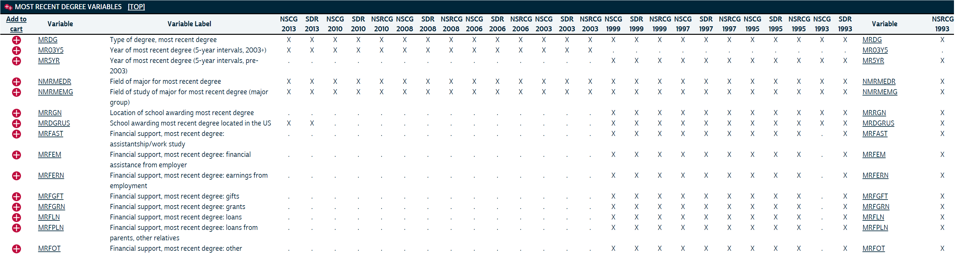

BACHELOR'S DEGREE

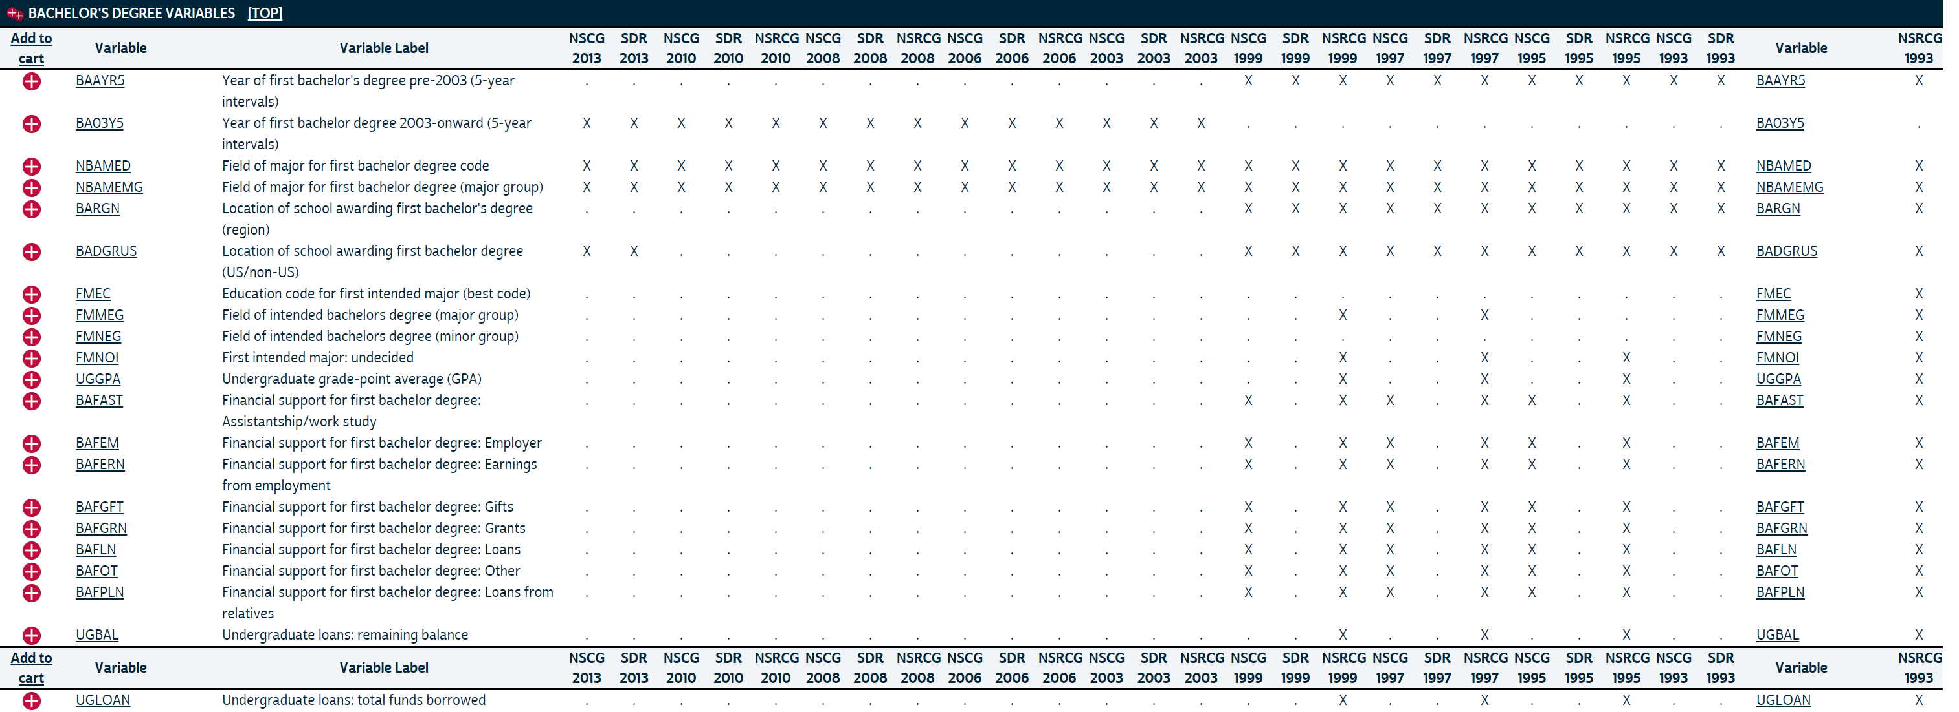

**Employment Variables**

EMPLOYMENT

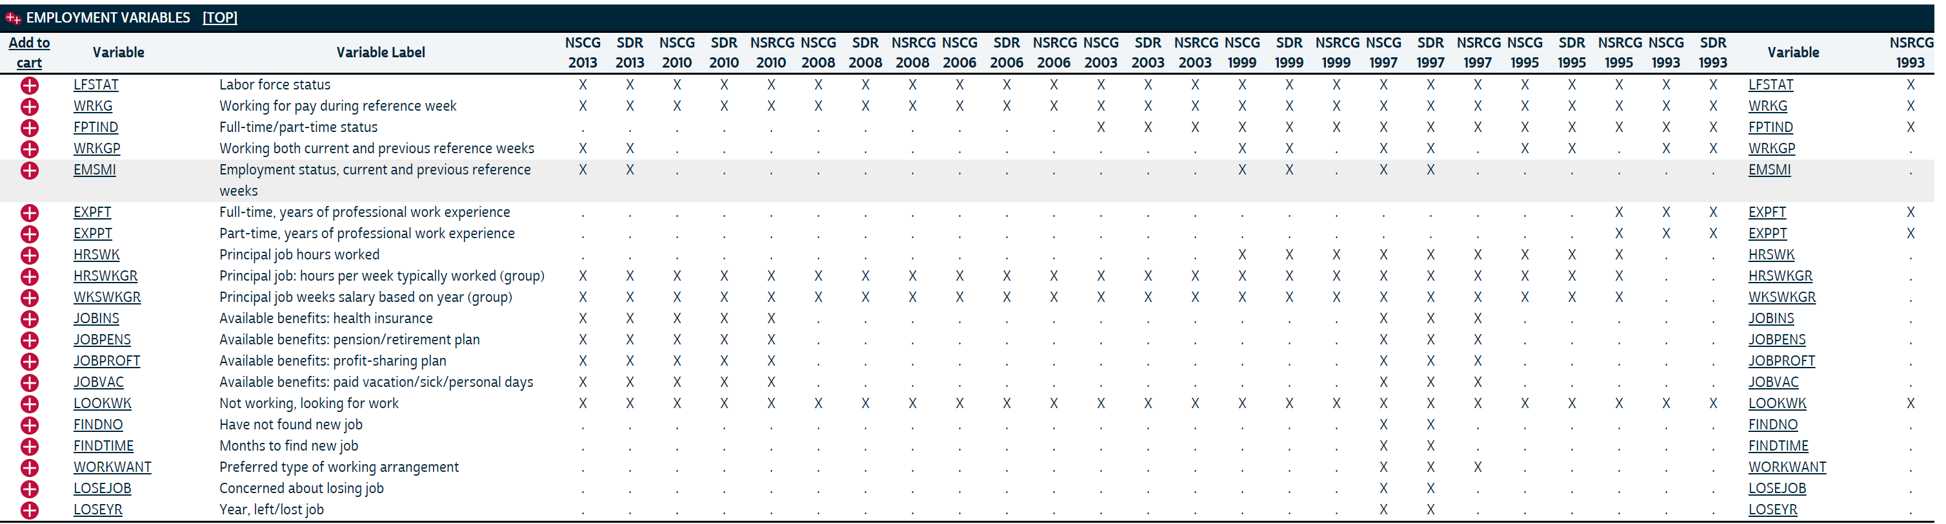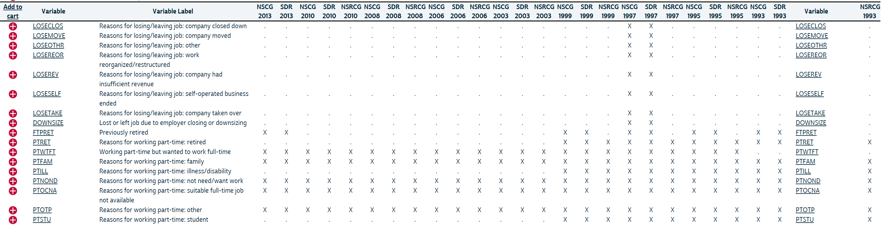

 OCCUPATION

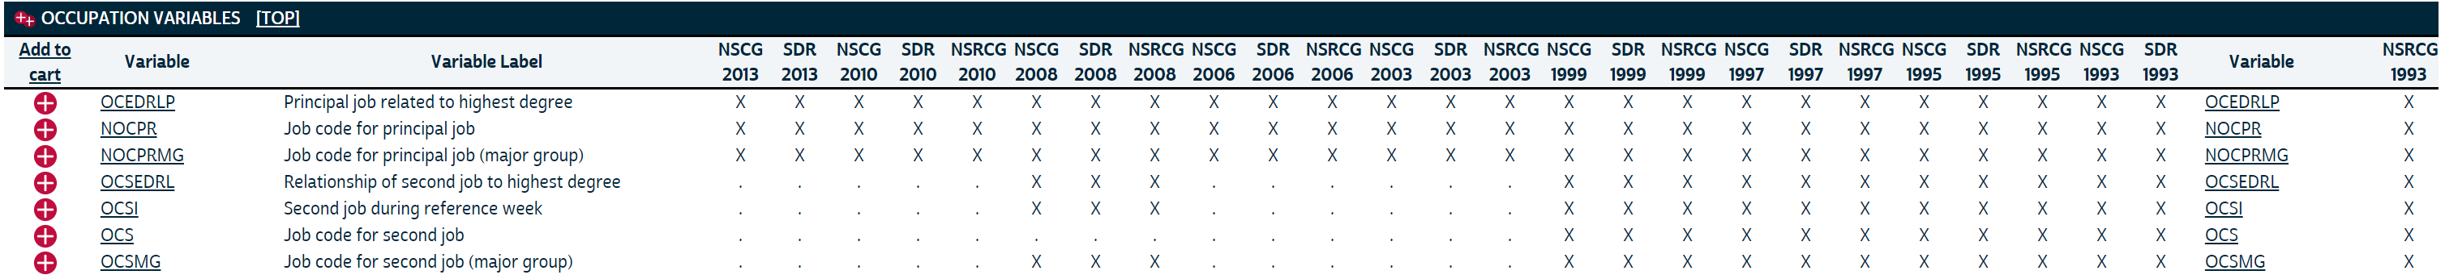

INCOME

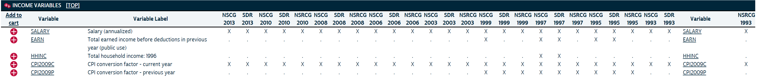

EMPLOYER CHARACTERISTICS

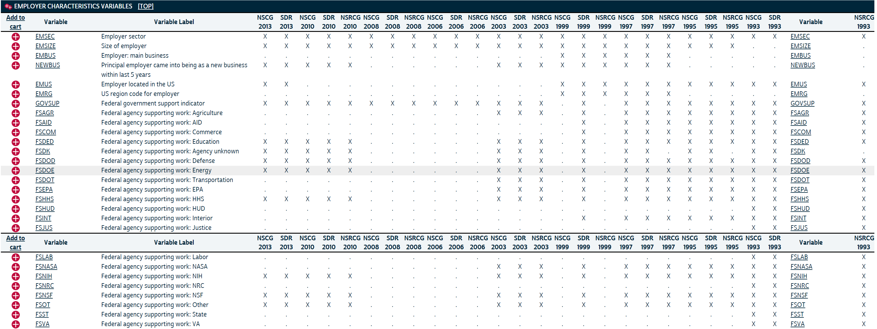

 WORK ACTIVITIES

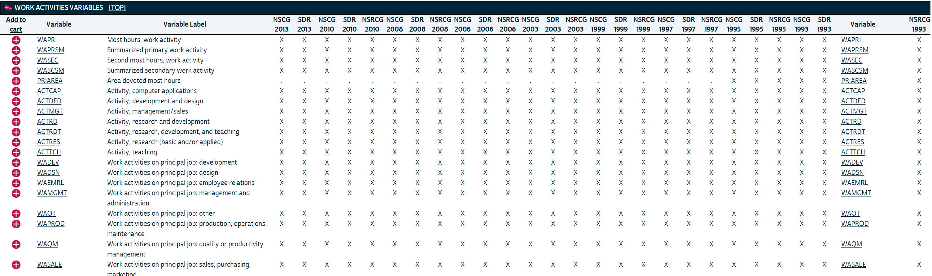

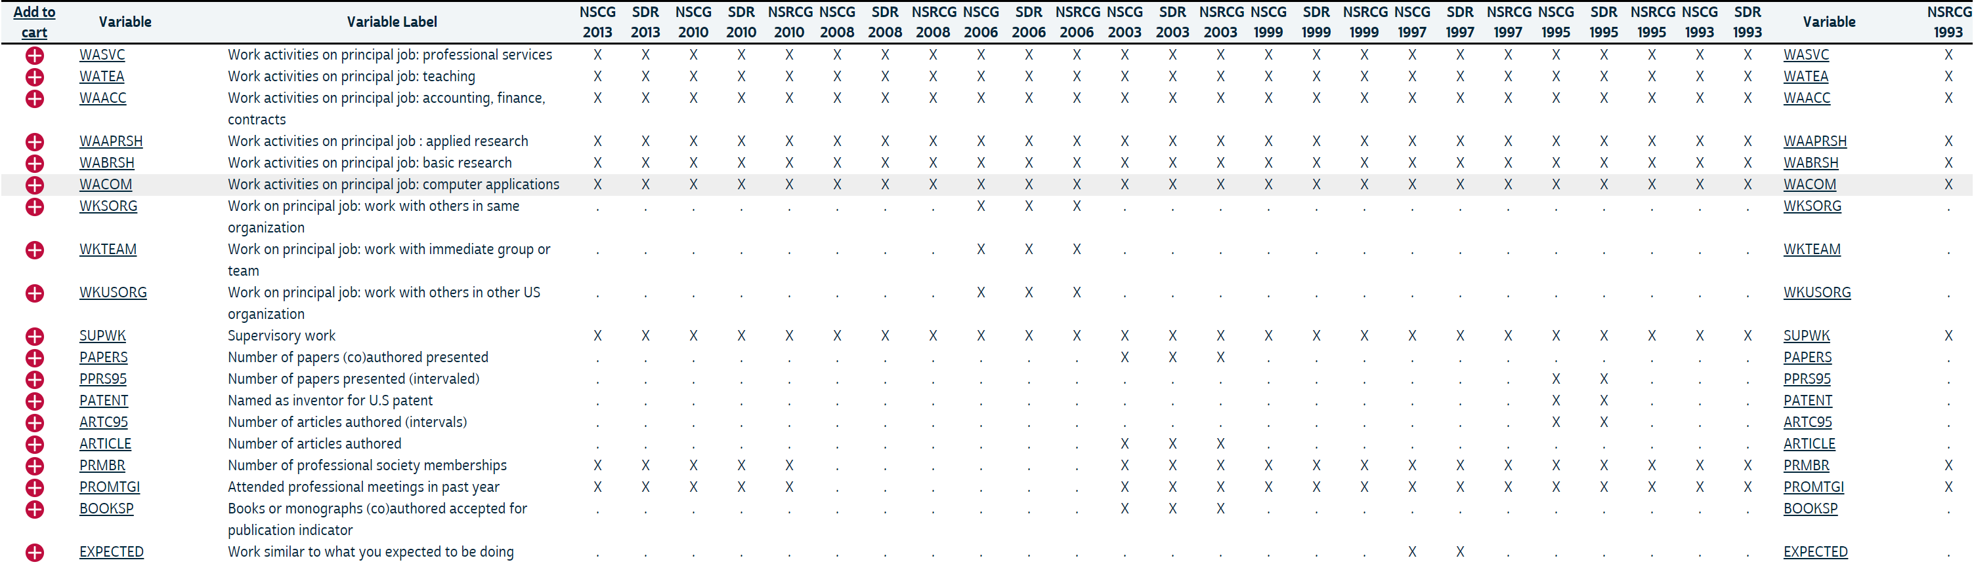

JOB SATISFACTION

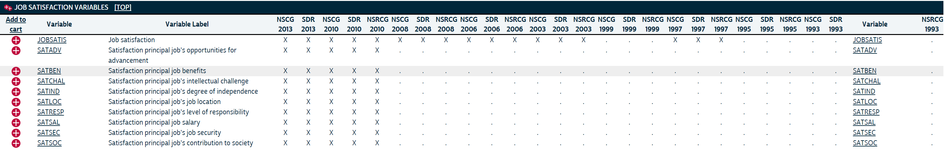

JOB TRAINING

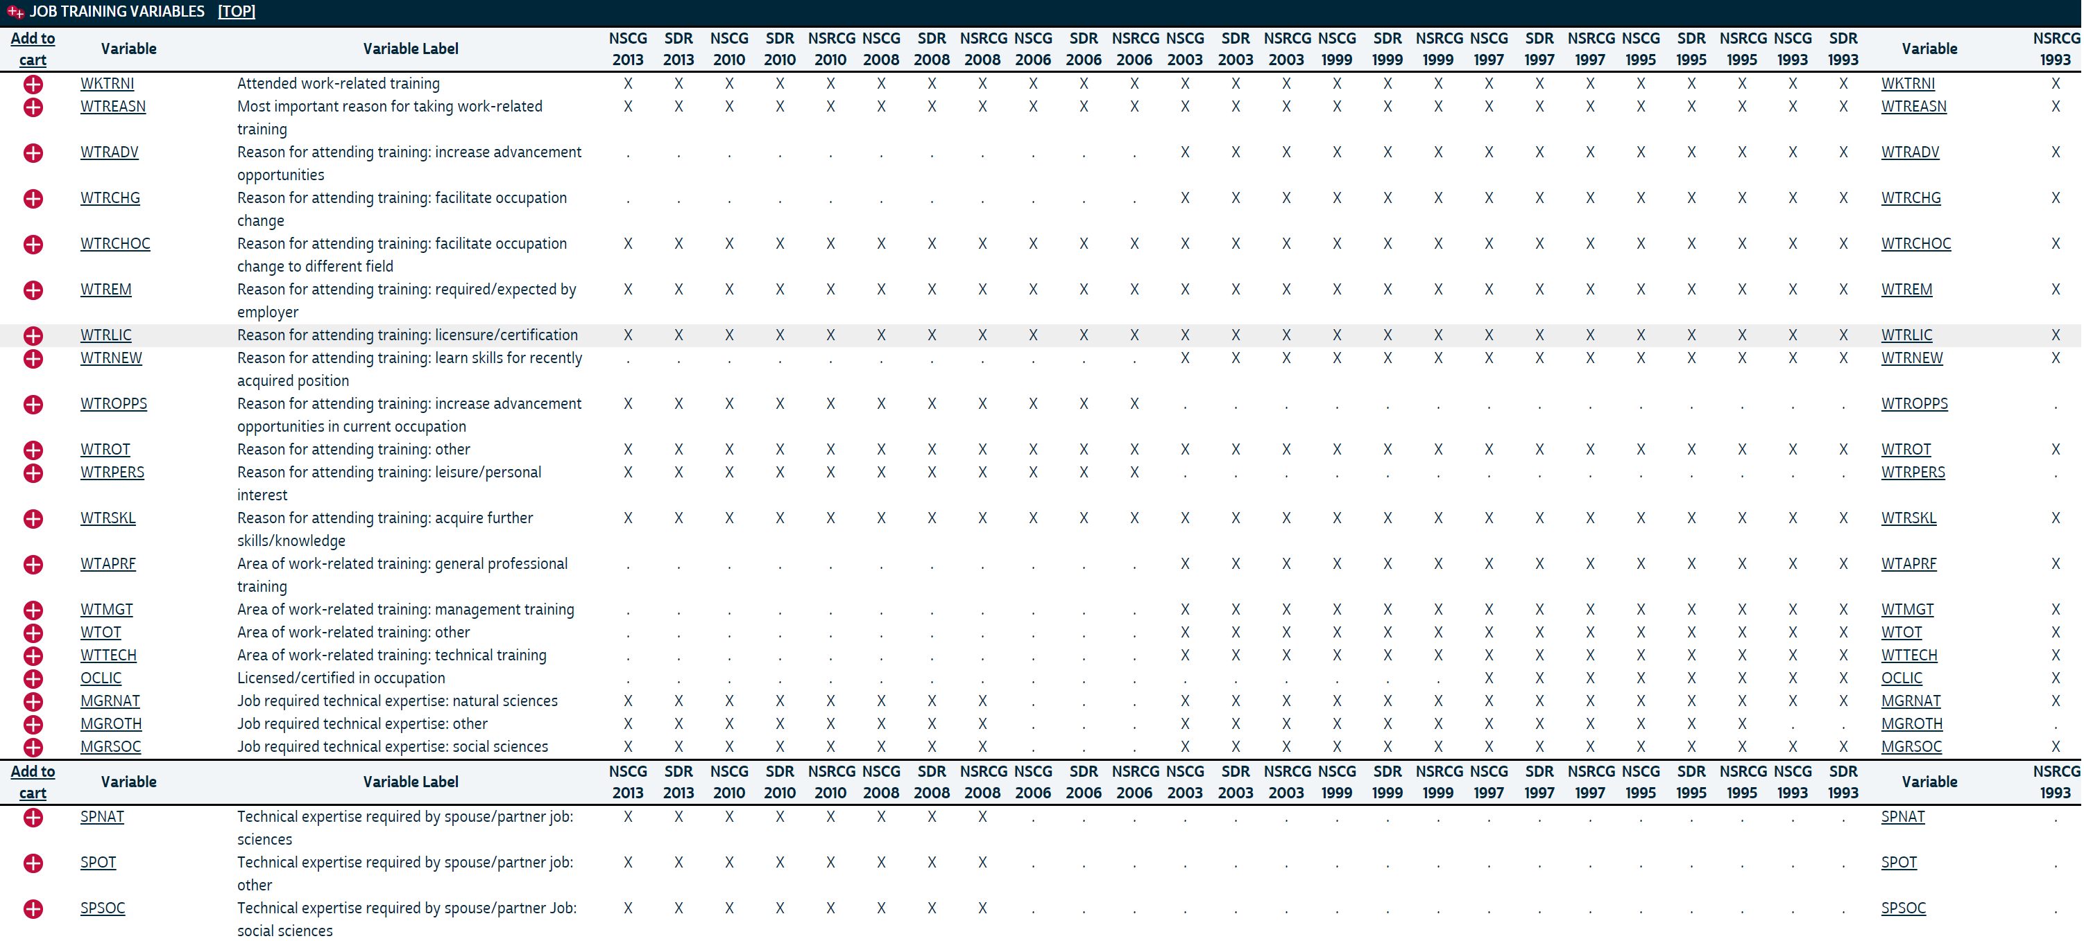

CAREER PATH

